Food Budgeter

by Akia Vongdara and Tim Wong

**Definition Statement**

Food Budgeter allows user to keep track of the cost of what they eat. By using this app, users can set a spending limit for themselves on food, and even discover new ways to spend their money. This financing app may be popular for those who want to know more about their spending habits and change it. It also differs from other competing app in the sense that it gives more detail on the ingredients bought and used.

**Brainstorm Features**

* Users can add details to items used for their recipes such as the price and store location.
* Create and store recipes
* Create a monthly and weekly budget
* Create a weekly diet and spending plan
* Recommend cheap restaurants
* Recipes has an approximate cost estimated by the prices of the items used.
* View list of recipes
* Sort recipes by cost, name, or time length
* Search up other user’s recipes
* Current items/ingredients database
* View Monthly/Weekly Budget

**Filtered Features**

* Users can add details to items used for their recipes such as the price and store location.
* Create and store recipes
* Create a monthly and weekly budget
* Recipes has an approximate cost estimated by the prices of the items used.
* View list of recipes
* View Monthly/Weekly Budget
* Sort recipes by cost, name, or time length
* Current items/ingredients database

**Market Research**

MoneyBook (3.5 stars)

* *Features*: Handles expenses and income. A handy overview of your previous transactions. Recording a transaction takes seconds. Rollover into following month. Number pad with calculation. Edit all your data at any time. Customizable categories. Set when your month starts. Switch between budget and salary mode. Progress over the previous months. Recurring monthly transactions.
* *Weaknesses*: You can only set a per month spending limit (or income) and watch your spendings go into different categories. Updating incomes changes past incomes as well.
* *Opinions*: The data in this app should be mutable.

Toshl (4 stars)

* *Features*: Compare the rate of your spending with the time of the month. One-time budgets, daily budgets, weekly budgets, bi-weekly budgets, monthly budgets, yearly budgets. Move remaining funds to the next budget. Learn from your budget history. Plan family bills for upcoming months and know how much you can spend. Works with any currency. Enter custom exchange rates.
* *Weaknesses*: Free version only allows one budget at a time.
* *Opinions*: A very good app, but everything is too generalized. You don’t really know what items you bought.

Mint (4.5 stars)

* *Features*: View all of your accounts including: checking, savings, credit cards, investments, and retirement. Mint automatically pulls in and categorizes your transactions. No need to enter your own transactions. Know how much you have left to spend. Mint creates a customized budget based on your actual spending. Add manual transactions at the time of purchase so you can track cash spending.
* *Weaknesses*: Generalizes purchases. You can’t know what you bought.
* *Opinions*: A very good app, but everything is too generalized. You don’t really know what items you bought.

**Sketches**

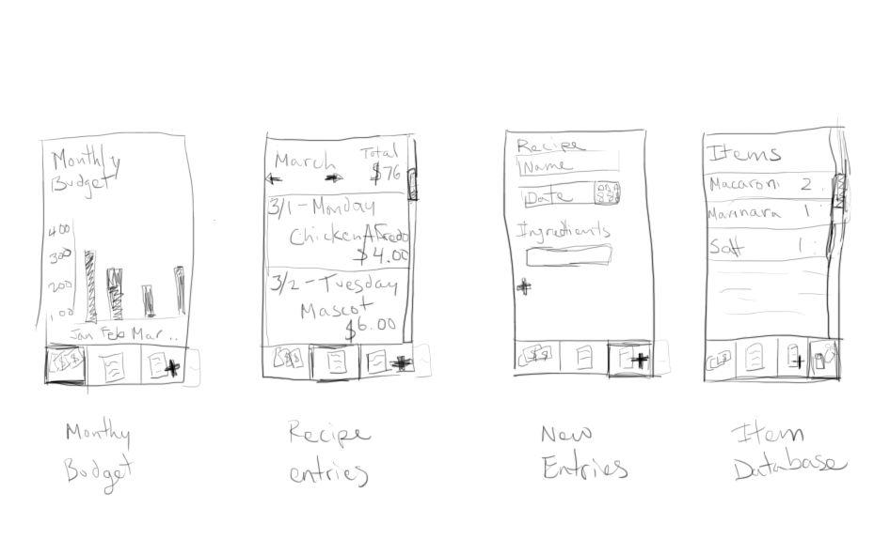

**Implementations**

Must-haves

* View Monthly Budgets
* Create Recipe Entries
* View Entries
* Item storing
* Recipes uses cost of items to estimate the cost of the meal
* Sort entries
* View Weekly Budgets
* Set budgets

If time allows

* Fuzzy Searching for items

Will not implement

* Create a weekly diet and spending plan
* Recommend cheap restaurants
* Search up other user’s recipes
* Accessible database by any user